PROJECT OVERVIEW
This Invoicing and Contracts Performance dashboard brings together contracts and ticketing data to give operations and finance leaders a live view of installation pipeline health, invoicing status, and support workload.​​
It tracks performance by current month, previous month, and onboarding cohorts, while also monitoring ticket volumes and backlog trends over the last six months.​
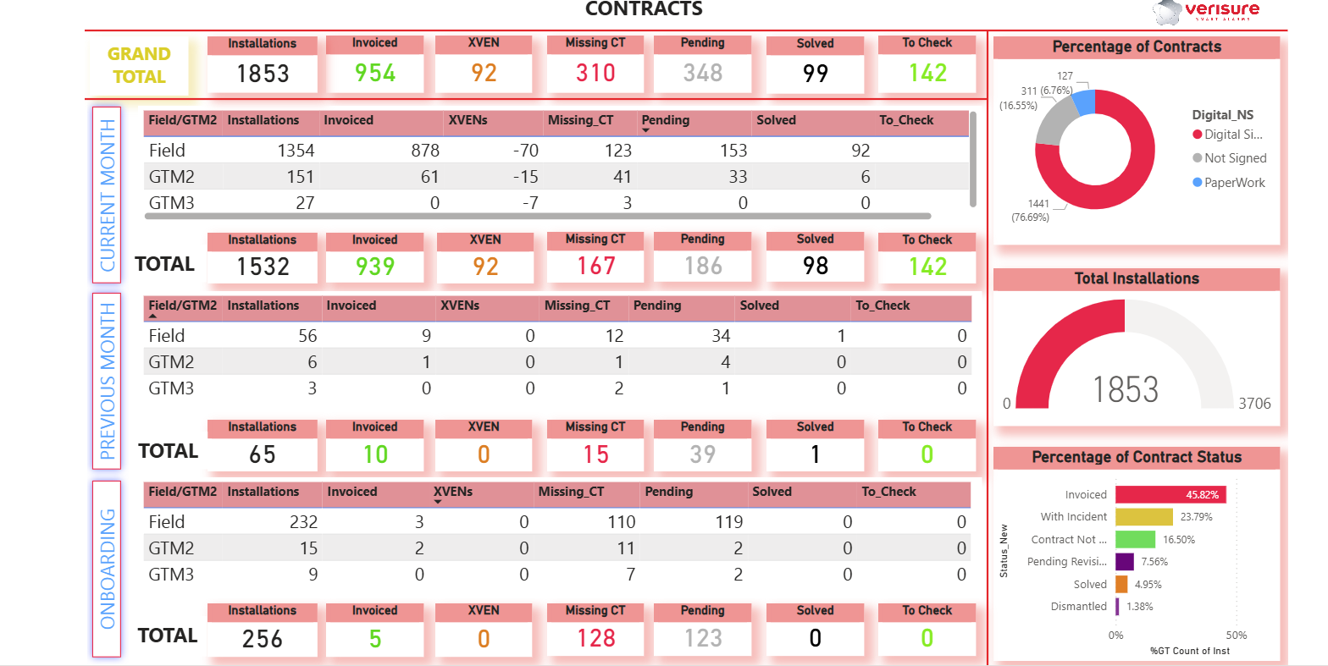
Contracts and invoicing overview
The Contracts section summarises total installations and their downstream status (invoiced, missing contract documentation, pending, solved, to check) at three levels: overall Grand Total, Current Month, Previous Month, and Onboarding.​
KPI cards and banded tables show how many installations are progressing smoothly to “Invoiced” versus those stuck in “Missing CT”, “Pending”, or “To Check”, allowing managers to quickly identify bottlenecks in the contract-to-cash process across Field, GTM2 and GTM3 teams.​​
Contract quality and portfolio mix
A donut chart for Percentage of Contracts splits the portfolio into digital signatures, signed, not signed, and paperwork, providing a clear view of contract quality and level of automation.​​
Additional visuals such as Total Installations and Percentage of Contract Status (e.g., invoiced, with incident, contract not received, pending review, solved, dismantled) help leadership understand both revenue readiness and operational risk in a single glance.​

Ticket volume and backlog management
The Tickets page tracks key support KPIs: total tickets opened and closed this month, tickets opened yesterday, tickets closed yesterday, and total final pending tickets (ticket backlog).​
Trend charts show tickets closed in the last 30 days and tickets opened in the last 6 months, enabling managers to see whether the team is consistently closing more tickets than are being opened or whether backlog is increasing.​
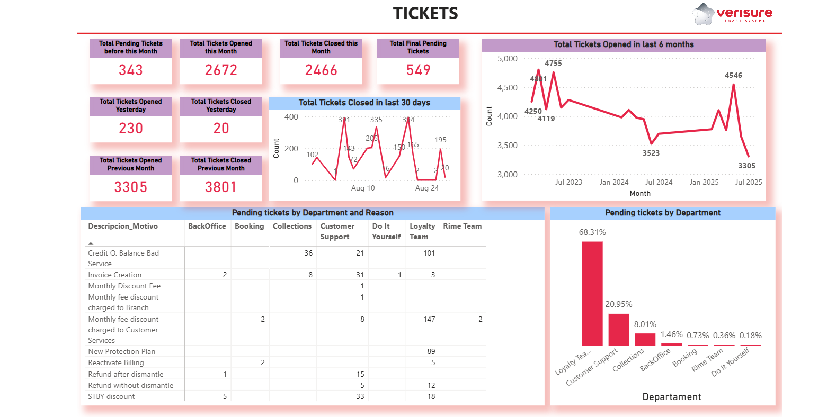
Root-cause analysis by department and reason
A detailed table of Pending tickets by Department and Reason breaks down open tickets by motive (billing issues, invoice creation, discounts, reactive billing, new protection plan, refunds, etc.) and by internal team (BackOffice, Booking, Collections, Customer Support, Do It Yourself, Loyalty Team, Rime Team).​
A supporting bar chart for Pending tickets by Department shows which team owns the largest share of unresolved work, helping leaders prioritise staffing, process improvements, or training where it will have the biggest impact on customer experience and cash collection.​
Power BI design and decision support
From a Power BI perspective, this dashboard combines KPI cards, time-series line charts, banded tables, and percentage visuals to follow best practices for operational invoicing dashboards—fast executive insight at the top, with drill-ready detail below.​​
By aligning contracts and ticketing metrics across current month, previous month, and onboarding, it gives stakeholders a clear understanding of how new installations convert into revenue, where paperwork or process gaps delay invoicing, and how support tickets impact the overall contract lifecycle.

